Linked List
Linked lists are among the simplest and most common data structures. In a linked list each node has a value and a pointer to the next node in the data structure.
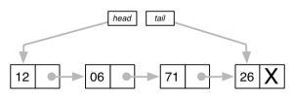

The principal benefit of a linked list over a conventional array is that the list elements can easily be inserted or removed without reallocation or reorganization of the entire structure because the data items need not be stored contiguously in memory or on disk, while an array has to be declared in the source code, before compiling and running the program.
Linked lists allow insertion and removal of nodes at any point in the list, and can do so with a constant number of operations if the link previous to the link being added or removed is maintained during list traversal.
A linked list data structure typically will have a head and a tail that point to the start and end of the data structure.
Generally you will have an addToHead() and addToTail functions that will insert new items at the beginning or end of the data structure.
To remove items there will be generally a removeHead() and a removeTail() functions.
To see if a linked list contains a value you will have a contains() function that will return true if the linked list contains the value or else returns false.

